POSITION DESCRIPTION |  | 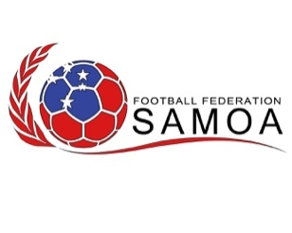
POSITION TITLE: | National U14 Head Coach
DEPARTMENT: | Technical Department
POSITION TYPE: | Fixed Term – April 2023 (Dates tbc)

RELATIONSHIPS
REPORTS TO: | Technical Director

ROLE PURPOSE
Directly oversee the training of the National U14’s Team preparation for the OFC U16 World Cup Qualifying Tournament.

MAIN RESPONSIBILITIES
Practical – Head Coach
- Support the implementation of all the national team preparation
  - Support all aspects of training
  - Support the logistical needs of the U16’s National Team including player data monitorization
  - Pro-active in terms of training organisation in all aspects

Administration – Head Coach
- Provide direct support to the Technical Director, including:
  - Support the logistical needs of the U16’s National team in all aspects
  - Update register on a session-by-session basis
  - Collate all player data as these leads towards tournament in January
  - Provide vital communication between all the players within the U16’s National Team.

PERSONAL PROFILE
CORE COMPETENCIES: | - Strong planning, organisational skills  - Able to manage self and others  - Open to new learning environments  - 100% attendance is required
QUALIFICATIONS, SKILLS AND EXPERIENCE: | - Senior Coaching License is advantageous C/B Or A License  - Current Youth/Senior Coach is advantageous  - Previous experience of competitions in the Oceania region is advantageous  - Excellent verbal communication skills  - Patience and the ability to remain calm in stressful situations
OTHER: | - Attention to detail  - Ability to work in a high-performance environment  - Ability to adapt to the needs of the group  - High ethical standards  - Professional in Appearance  - Honest and Hardworking
Any other duties directed by FFS.

