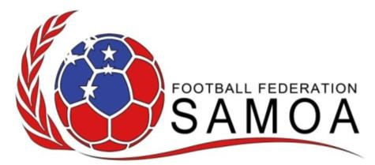

**OFFICIAL PRESS RELEASE**

6 March 2025

**Football Federation Samoa Officially Announces**

**Appointment of New Chief Executive Officer**

The Football Federation Samoa is pleased to officially announce the appointment of Faumuina Margaret Pauline G. Crichton as the new Chief Executive Officer (CEO), effective 3 March 2025.

Faumuina Margaret also known as Polly brings a wealth of experience in sports administration and leadership, with over 15 years working in the Private Sector and for the Government of Samoa. Prior to joining the Federation, she co-owned with her husband a real estate business together. Prior to that she worked in government for which she was Assistant Chief Executive Officer in Corporate Services looking after Finance, Budget, Administration, Human Resources, Assets and Records Divisions (2 full terms contractual of 3 years) for 6 years with the Ministry of Communications and Information Technology.

Faumuina Margaret is a former Independent Finance Board Member of Lakapi Samoa and a former Vice President of Marist St Joseph’s Sports Club in Samoa. She is also a former national representative player in both Football and Hockey in her playing days and is very familiar with the Sports Ecosystem in Samoa.

Faumuina Margaret holds both a Bachelor of Commerce degree and a Master of Science Degree (MSc) with Merit in Accounting and Finance from the UK and Samoa.

As CEO, Faumuina Margaret will be responsible for leading the strategic direction of the Federation, enhancing the development of football at all levels, and driving forward key initiatives to grow the game across the country and lift the profile of football in Samoa to the world.

“We are thrilled to welcome Faumuina to the Federation,” said Papalii - President of Football Federation Samoa. “Her leadership, vision, and passion for the sport as a former National Rep together with her business and corporate knowledge from both the private and public sector will be instrumental in helping us achieve our goals for the future of football.”

“She comes at a time where the federation is quite busy with the numerous infrastructure projects its involved with, but also with the numerous development projects as well as coordinating the numerous National Teams playing around the the region as well as preparing its first team for a FIFA world cup tournament so every bit of experience and knowledge in getting through all these is greatly needed…”.

In accepting the role, Faumuina expressed excitement about the opportunity:

As a former football player myself, over the years I’ve looked from afar whilst living overseas in UK and wished I was still in Samoa to help out with the youth developments and since I came home I wanted to offer my services to the game I love and see how we can grow it further. I am committed to working closely with the Board, our stakeholders, clubs, players, and communities to build a stronger, more inclusive, and successful future for football.”

The Federation and its Board looks forward to working with Faumuina’s leadership as it continues to grow the beautiful game and deliver positive outcomes both on and off the pitch.

END!