Job Description

Position Title - Competition Officer

Purpose of the Position
The Competitions Officer is responsible for coordinating, organizing, and delivering all Samoa Football competitions and tournaments. The role ensures competitions run smoothly, match information is accurate, and all stakeholders receive timely support and communication.

Key Relationships
Responsible to: Competition Manager

Key Responsibilities
(1) Competition Administration
- Coordinate the planning, scheduling, and delivery of all national leagues and tournaments.
- Prepare fixtures, competition calendars, and match documentation.
- Oversee venue readiness, match logistics, and operational requirements.

(2) Data & Compliance
- Ensure results, match sheets, and reports are correctly entered into COMET.
- Monitor club compliance with competition regulations and player registrations

(3) Stakeholder Communication
- Serve as the main contact for clubs regarding competition matters.
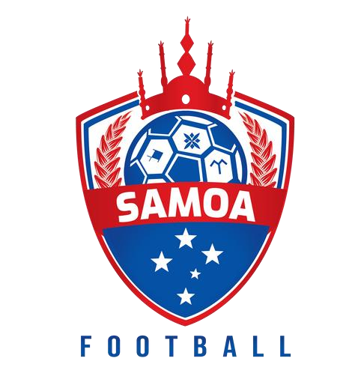
- Coordinate with departments such as Referees, Technical, Media, and Development.

(4) Other
- Assist with tournament setup, opening ceremonies, finals, and presentation logistics.
- Support emergency matters (weather delays, rescheduling, disciplinary issues).

Selection Criteria Minimum Qualifications
- Diploma in Sports Management, Business, or related discipline • Experience in administration or sports operations is an advantage.
- Knowledge of football competition structures (desirable)

Skills & Competencies
- Strong organizational and coordination skills.
- Proficient with Microsoft Office and able to learn COMET quickly.
- Excellent communication and stakeholder management.
- Ability to work weekends and under pressure.
- Good problem-solving and attention to detail.

Personal Attributes
- Reliable, honest, and committed to football development.
- Team-oriented with a positive attitude.
- Able to work in a fast-paced environment.
- Must hold a valid driver’s license, experience driving manual vehicles is an advantage.

